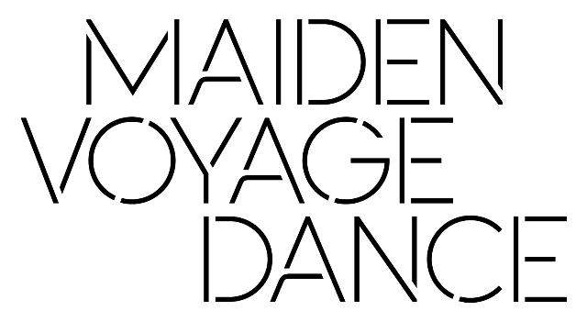
Maiden Voyage has been awarded Organisational Emergency Funding from the Arts Council of Northern Ireland and Department for Communities for Resi-dance, a programme of seed commissions and creative practice development for NI-based dance artists during the Covid pandemic.
The opportunities provided by Resi-dance include;
- Five Seed Commissions
Five seed commissions for five dance artists at various and pivotal stages of their careers to research and develop work in new contexts for future Covid-safe live presentation. These can include but are not limited to; outdoor urban environments, natural world, durational or installation-based performance or site responsive performance.
There is a maximum of up to £4500 for each commission development.
- Dance Days
Opportunity for 5 other freelance dance artists to have two paid days to reflect on their shifting practice, ways of working, changing roles or training and development.
Five artists will receive 2 dance days each at £130 per day.
- Intensives
A series of free discussions & training sessions open to the dance sector will be hosted in 2021. No application is necessary. Please refer to www.maidenvoyagendance.com for more details in the new year.
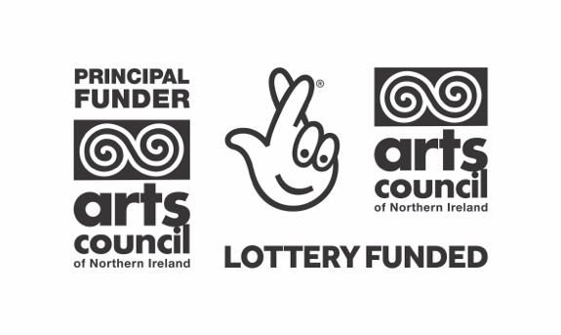
Submission Details:
- Lead artist and collaborators must be based in NI and not be in full-time education.
- You must not be in receipt of funding from ACNI SIAP or ACNI Individual Emergency Funds or other funded supports for this submission.
- The submission should be for development of a new work suitable for non-theatre presentation ideally in Belfast or a specified location nearby.
- Due to ongoing Covid restrictions, work should be developed adhering to physical distancing and other Covid safe measures.
- Budgets should be for than maximum of £4,000 in fees and up to £500 for other costs essential to your submission if required.
- Successful submissions must be developed before 14 Feb 2021. Final presentation will not take place until later in 2021 subject to further funds being secured.
- You can apply for one or both A and B. However, if you are selected for A you will not be eligible for B and vice versa.
- You can only submit one proposal for A as the lead artist. You can be named as a collaborator on a different submission.
- Please complete and submit the forms along with any required CVs/biogs.
- Submissions should be emailed as word, pages or pdf format to nicola@maidenvoyagedance.com with clearly marked email heading Resi-dance submission.
- Should you prefer, you can submit a video talking to camera (no more than 3 minutes) to outline your idea and how you would benefit. Please submit this via wetransfer to the email listed above by the deadline along with your budget, biogs and the other details required on the form.
- Submission deadline is Wednesday 9 December 2020 at noon. Late or incomplete submissions will not be considered.
- Decisions will be communicated by or on Friday 18 December 2020.
Criteria
Through Resi-dance Maiden Voyage is seeking to support a wide range of freelance dance artists at various and pivotal career stages. Submissions for seed commissions should align with Maiden Voyage’s aim to offer new discoveries in dance with, by and for artists, audiences and participants and will be selected to ensure presentation in a range of spaces and locations with potential for performance in 2021. Proposal for dance days should demonstrate how it will support your development at this time. Decisions will be made by Maiden Voyage Artistic Director Nicola Curry, Company Manager Sandy Cuthbert and confirmed by Maiden Voyage Board.
RESI-DANCE

- Seed Commission Submission

Lead Artist Name:
Please submit CV
Are you a | Recent Dance Graduate  Early Career Dance Artist  Established Dance Artist  Other:
Address:
Postcode:
Email:
Mobile:
Collaborators:
Please submit Biogs.
Link to showreel:
3m in max
Work suitable for: | ie: a specific location / installation /durational / urban / rural
Proposal Outline:
Max 300 words or film yourself talking up to max 3 mins and must include how you will benefit.
How you will benefit:
Max 100 words or film yourself talking as above.

Proposal Budget:  Max available up to £4000 and up to £500 for other costs ie space hire. | Please outline your proposed budget taking into consideration appropriate fee payment for each artist involved.

RESIDANCE

- Dance Days Submission

Artist Name:
Please submit CV/biog
Are you a | Recent Dance Graduate  Early Career Dance Artist  Established Dance Artist  Other:
Address:
Postcode:
Email:
Mobile:
What you wish to do:
200 words max or submit 3 min of you talking and include how you will benefit
How will you benefit from this:
100 words max

